Aspect Based Sentiment Analysis with Gated Convolutional Networks

1 Introduction

A number of models have been developed for ABSA, but there are two different subtasks, namely aspect-category sentiment analysis(ACSA) and aspect-term sentiment analysis(ATSA). The goal of ACSA is to predict the sentiment polarity with regard to the given aspect, which is one of a few predefined categories. On the other hand, the goal of ATSA is to identify the sentiment polarity concerning the target entities that appear in the text instead, which could be a multi-word phrase or a single word.

In this paper, we propose a fast and effective neural network for ACSA and ATSA based on convolutions and gating mechanisms, which has much less training time than LSTM based networks, but with better accuracy.

2 Related Work

2.1 Neural Networks

2.2 Aspect based Sentiment Analysis

Aspect-Term Sentiment Analysis

Aspect-Category Sentiment Analysis

3 Gated Convolutional Network with Aspect Embedding

In this section, we present a new model for ACSA and ATSA, namely Gated Convolutional network with Aspect Embedding (GCAE), which is more efficient and simpler than recurrent network based models.

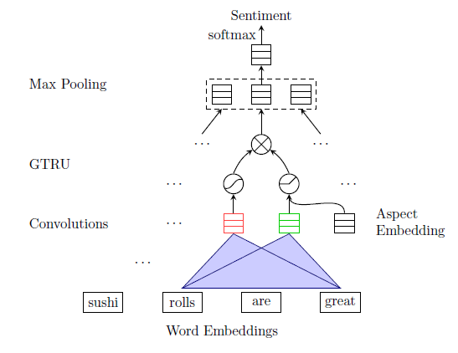

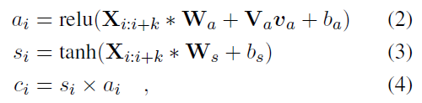

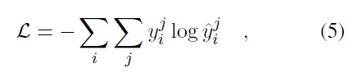

where i is the index of a data sample, j is the index of a sentiment class.

4 Gating Mechanisms

5 GCAE on ATSA

ATSA task is defined to predict the sentiment polarity of the aspect terms in the given sentence.

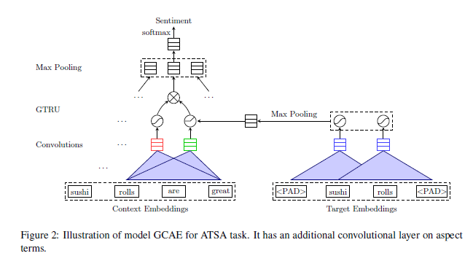

6 Experiments

6.1 Datasets and Experiment Preparation

6.2 Compared Methods

6.3 Results and Analysis

6.3.1 ACSA

6.3.2 ATSA

6.4 Training Time

6.5 Gating Mechanisms

7 Visualization

8 Conclusions and Future Work

In this paper, we proposed an efficient convolutional neural network with gating mechanisms for ACSA and ATSA tasks. GTRU can effectively control the sentiment flow according to the given aspect information, and two convolutional layers model the aspect and sentiment information separately. We prove the performance improvement compared with other neural models by extensive experiments on SemEval datasets. How to leverage large-scale sentiment lexicons in neural networks would be our future work.